

Packet Tracer - Point-to-Point Single-Area OSPFv2 Configuration

Nombre:Luis Enrique Pérez Señalin Martes, 7 de Mayo de 24

# Addressing Table

|  |  |  |  |
| --- | --- | --- | --- |
| **Device** | **Interface** | **IP Address** | **Subnet Mask** |
| R1 | G0/0/0 | 192.168.10.1 | /24 |
|  | S0/1/0 | 10.1.1.1 | /30 |
|  | S0/1/1 | 10.1.1.5 | /30 |
| R2 | G0/0/0 | 192.168.20.1 | /24 |
|  | S0/1/0 | 10.1.1.2 | /30 |
|  | S0/1/1 | 10.1.1.9 | /30 |
| R3 | G0/0/0 | 192.168.30.1 | /24 |
|  | S0/1/0 | 10.1.1.10 | /30 |
|  | S0/1/1 | 10.1.1.6 | /30 |
| PC1 | NIC | 192.168.10.10 | /24 |
| PC2 | NIC | 192.168.20.10 | /24 |
| PC3 | NIC | 192.168.30.10 | /24 |

**Objectives**

**Part 1: Configure Router IDs.**

**Part 2: Configure Networks for OSPF Routing. Part 3: Configure Passive Interfaces.**

**Part 4: Verify OSPF configuration.**

# Background

In this activity, you will activate OSPF routing using network statements and wildcard masks, configuring OSPF routing on interfaces, and by using network statements quad-zero masks. In addition, you will configure explicit router IDs and passive interfaces.

# Instructions

**Part 1: Configure router IDs.**

1. Start the OSPF routing process on all three routers. Use process ID **10**.

Router(config)# **router ospf** *process-id*

1. Use the router-id command to set the OSPF IDs of the three routers as follows
   * R1: **1.1.1.1**
   * R2: **2.2.2.2**
   * R3: **3.3.3.3**

Use the following command:

Router(config-router)# **router-id** *rid*

# Part 2: Configure Networks for OSPF Routing

## Step 1: Configure networks for OSPF routing using network commands and wildcard masks.

How many statements are required to configure OSPF to route all the networks attached to router R1?

**R:** We need 3 statements for 3 differents networks.

The LAN attached to router R1 has a /24 mask. What is the equivalent of this mask in dotted decimal representation?

**R**: The /24 submask is equivalent to 255.255.255.0

Subtract the dotted decimal subnet mask from 255.255.255.255. What is the result?

**R:** 255.255.255.255 subtracted 255.255.255.0 is 0.0.0.255 this is the wildcard.

What is the dotted decimal equivalent of the /30 subnet mask?

**R:** The /30 submask is equivalent to 255.255.255.252

Subtract the dotted decimal representation of the /30 mask from 255.255.255.255. What is the result?

**R:** 255.255.255.255 subtracted 255.255.255.252 is 0.0.0.3 this is the wildcard.

1. Configure the routing process on R1 with the network statements and wildcard masks that are required to activate OSPF routing for all the attached networks. The network statement values should be the network or subnet addresses of the configured networks.

Router(config-router)# **network** network-address wildcard-mask **area** area-id

1. Verify that OSPF has been configured properly by the displaying the running configuration. If you find an error, delete the network statement using the **no** command and reconfigure it.

## Step 2: Configure networks for OSPF routing using interface IP addresses and quad- zero masks.

On router R2, configure OSPF using network commands with the IP addresses of the interfaces and quad- zero masks. The syntax of the network command is the same as was used above.

## Step 3: Configure OSPF routing on router interfaces

On router R3, configure the required interfaces with OSPF. Which interfaces on R3 should be configured with OSPF?

Configure each interface using the command syntax shown below:

Router(config-if)# **ip ospf** *process-id* **area** *area-id*

# Part 3: Configure Passive Interfaces

OSPF will send its protocol traffic out of all interfaces that are participating in the OSPF process. On links that are not configured to other networks, such as LANs, this unnecessary traffic consumes resources. The passive-interface command will prevent the OSPF process from sending unnecessary routing protocol traffic out LAN interfaces.

Which interfaces on R1, R2, and R3 are a LAN interfaces?

Configure the OSPF process on each of the three routers with the **passive-interface** command.

Router(config-router)# **passive-interface** *interface*

# Part 4: Verify OSPF Configuration

Use **show** commands to verify the network and passive interface configuration of the OSPF process on each router.

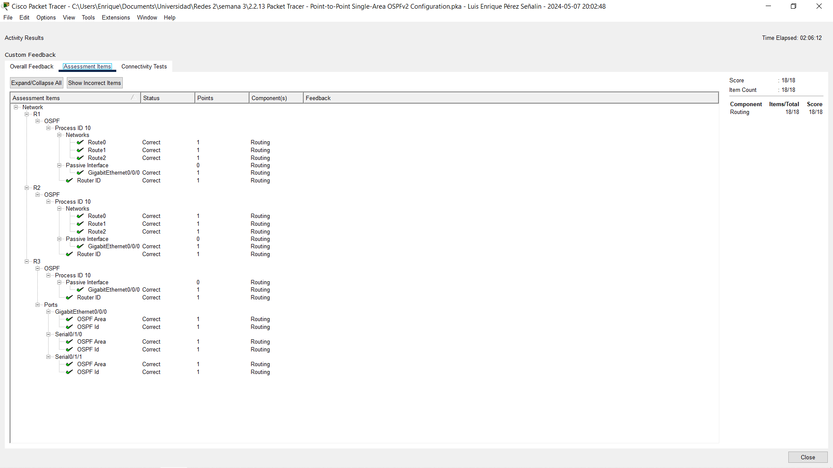 **Captura de pantalla**